Project Design Phase
Solution Architecture
Date | 27 September 2026
Team ID
Project Name | Metro Ticket Generating System Using ServiceNow
Maximum Marks | 4 Marks

Solution Architecture:
Solution architecture bridges the gap between business problems and technology solutions. Its goals are to:
- Find the best tech solution to solve existing business problems.
- Describe the structure, characteristics, behavior, and other aspects of the software to project stakeholders.
- Define features, development phases, and solution requirements.
- Provide specifications according to which the solution is defined, managed, and delivered.
Solution Architecture Diagram
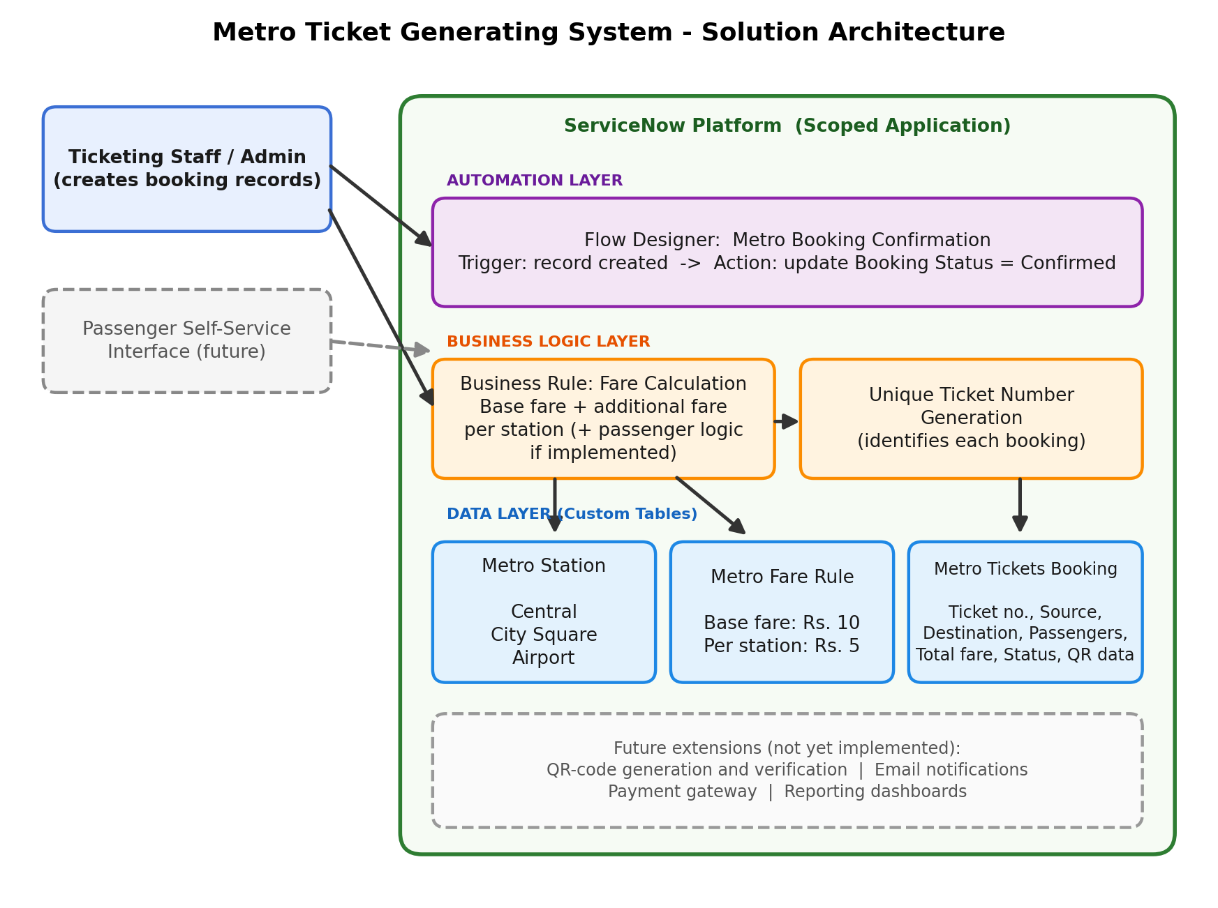
Figure 1: Architecture and data flow of the Metro Ticket Generating System
Architecture Components
Layer | Components | Role
Data layer | Metro Station, Metro Fare Rule and Metro Tickets Booking custom tables | Store stations (Central, City Square, Airport), the fare configuration (₹10 base, ₹5 per station) and the booking records.
Business logic layer | Fare calculation Business Rule; unique ticket number | Calculates the total fare from the selected journey and fare rule; gives each booking its own ticket number.
Automation layer | Flow Designer flow “Metro Booking Confirmation” | Triggered when a booking record is created; updates the booking status to Confirmed.
Future extensions | QR Code Data field, notifications, payments, self-service portal, dashboards | Proposed enhancements; the QR Code Data field only reserves a place for QR information.
Data Flow
- A booking record is created in the Metro Tickets Booking table with the source station, destination station and passenger count.
- The Business Rule reads the station and fare rule data and calculates the total fare.
- The booking is identified by its unique ticket number.
- The Metro Booking Confirmation flow runs on record creation and sets the booking status to Confirmed.
The exact order of the Business Rule, ticket number generation and flow depends on their configured triggers and timing.
Implementation Notes
- Reported test: Central to Airport, one passenger, produced a total fare of ₹20.
- The flow should be treated as fully operational only after it is activated and tested end to end.
- QR-code generation and verification, notifications, payment and a passenger interface are future enhancements.
- The fare structure is a simplified demonstration configuration, not official metro fares.
Reference: ServiceNow Developer Portal – https://developer.servicenow.com and ServiceNow Product Documentation – https://www.servicenow.com/docs/

